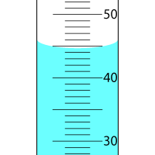
In the picture a meniscus is viewed on a graduated cylinder. Volumes are measured in milliliters and each tick mark represents a single milliliter (ml). Report the volume in milliliters (ml). Remember to report numbers using the number of significant figures allowed by the scale on the device.
If the mass of the liquid in this graduated cylinder was recorded to be 15.36 grams, what would the density of the liquid be in grams/milliliter. Remember to report with the appropriate number of significant figures.
What would the density of the liquid be in grams/Liter

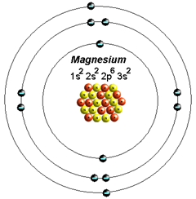
2. Discuss the concept of density. What is it a measure of? Explain how a substances atomic composition (what specific atom types compose the material) affects its density. Think of the differences in the densities of lithium and magnesium discussed in lecture. Remember that these two atoms have very similar volumes but vary greatly in their numbers of subatomic particles.
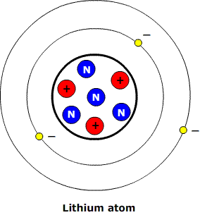

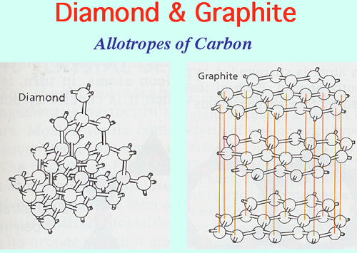
Explain how the specific three-dimensional arrangement of atoms in a material affect the materials density. Think in terms of the differences in the densities of graphite and diamond. In this case the two materials are both made of only carbon atoms and yet their densities are very dissimilar. The density of graphite is about 2.2 g/ml and the density of diamond is about 3.5 g/ml. Why do the two materials differ in their densities?

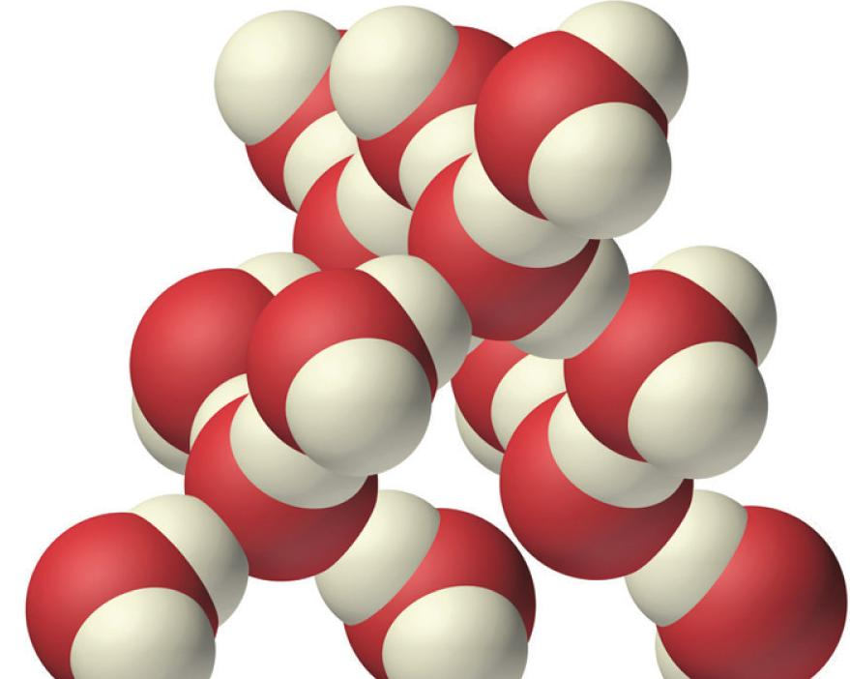
3. Suppose a one nanometer cubed volume of liquid water contains twelve water molecules. A molecule of water is composed of one oxygen atom and two hydrogen atoms. A single oxygen atom has a mass of 2.657 x 10⁻²³grams. A single hydrogen atom has a mass of 1.674 x 10⁻²⁴grams. Calculate the density of this volume of water in grams per nanometer cubed (g/nm³). Convert this density to grams per milliliter (g/ml). Based on the accepted value of the density of liquid water (you should know this value), did your instructor make a good guess at how many molecules of water would be present in a 1nm³ volume?

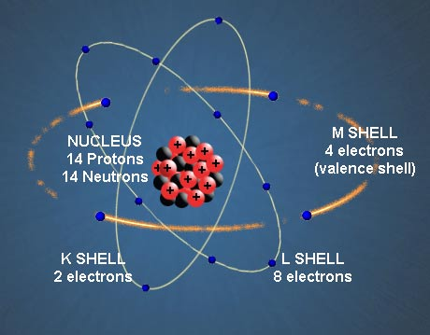
4. The neutrally charged silicon atom (²⁸Si) has 14 protons, 14 neutrons and 14 electrons. The atomic radius of a silicon atom is 0.111 nanometers. Use this information to calculate the density of this silicon atom in grams per nanometer cubed. Volume of a sphere = 4/3πr³. Proton mass = 1.673 x 10⁻²⁴grams. Neutron mass = 1.675 x 10⁻²⁴grams. Electron mass = 9.11 x 10⁻²⁸grams.
A common isotope of silicon is ²⁹Si. Determine the density of this silicon atom. How many protons, neutrons and electrons does this silicon atom have?
An ion of silicon is Si⁺ (atom has a positive charge of +1) how many protons, neutrons and electrons does this silicon atom have?

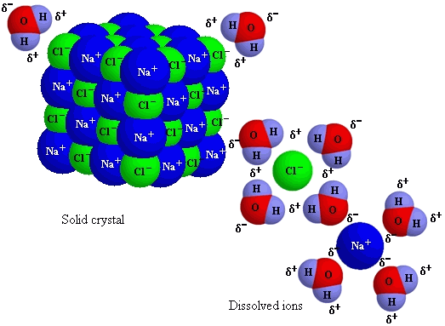
5. In the picture, solid sodium chloride (an ionic compound) is interacting with liquid water. Contrast how the water molecules interact with a sodium ion to how they interact with a chloride ion. What is it about the distribution of electrons in the water molecule that causes it to behave differently around a sodium ion than it does around a chloride ion? How is the oxygen atom responsible for this behavior? Is sodium chloride soluble in water (does it mix)?

6. When Rutherford was investigating the properties of the atom he designed an experiment where he fired alpha-particles (a positively charged particle with two protons and two neutrons) at a thin piece of gold foil. He was surprised that the majority of the particles passed right through the foil. He was even more surprised that some of the particles bounced right back at him! What part of the atom were the alpha-particles colliding with and what subatomic particles compose this part of the atom? Why does it make sense that a collision of an alpha-particle with this part of the gold atom would deflect the particles path? Would the charge on this part of the atom tend to attract or repel an alpha-particle?
Why did most of the alpha-particles pass right through the gold foil and which subatomic particles occupy the space they passed through? Would you expect a collision of an alpha particle with one of these subatomic particles to result in a deflection of the particles path? Why?
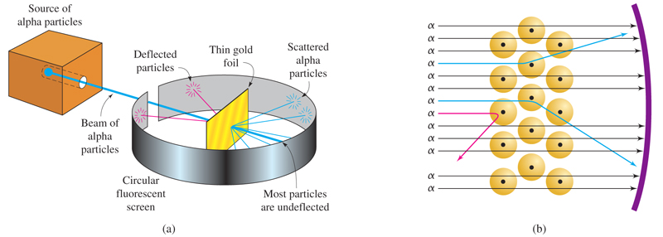

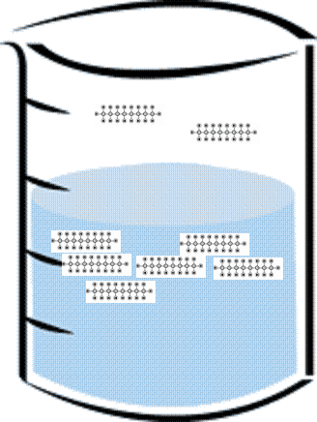
7. The boiling point of octane is 125⁰C. The heat capacity of octane is 2.24 Joules/gram ⁰C. How many Joules of energy would be required to bring a 150 gram volume of octane to its boiling point from an initial temperature of 80⁰C? Describe what is happening at the boundary between the liquid and gas phases of octane when the boiling point is reached. Describe the nature of the forces acting to keep the molecules in the liquid phase and describe the nature of forces acting to drive the molecules into the gas phase. The two competing forces illustrate two kinds of energy discussed in lecture, kinetic energy and potential energy. Which of the opposing forces is caused by kinetic energy and which is caused by the potential energy of an electrostatic field?
Are the interactions responsible for the mutual attraction between two octane molecules polar or non-polar interactions? Would you expect the boiling point of a longer chain hydrocarbon such as Decane to be higher or lower than the boiling point of octane? Why?

8. Are octane and water miscible? Explain in terms of the kinds of attractive interactions the two molecules are inclined to have with other molecules.

