Chapter 16 Review Questions

2. Is the reaction N₂O₄ ↔ 2NO₂ exothermic or endothermic? (Figure 16.1)

3. Why is heat treated as a reactant in an endothermic process and as a product in an exothermic process?

12. Why does the rate of a reaction usually increase when the concentration of one of the reactants is increased?

14. Why does an increase in temperature cause the rate of reaction to increase? Think in terms of collisions being necessary for a reaction to occur.

15. What does a catalyst do?

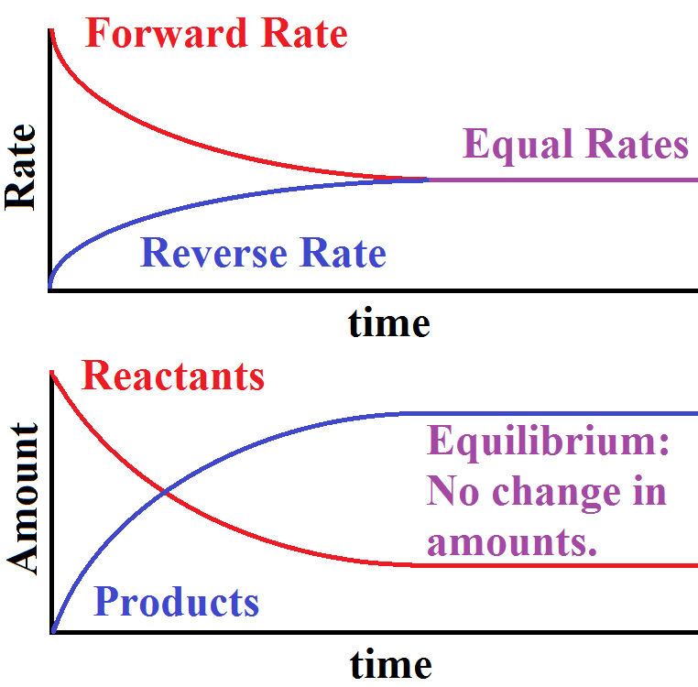
16. Describe how equilibrium is reached when the substances A and B are first mixed and react as
A + B ↔ C + D
Reactants ↔ Products

refer to figure.

Chapter 16 Paired Excersizes

3. Consider the following system at equilibrium:

SiF₄(g) + 2 H₂O(g) + 103.8 kJ ↔ SiO₂(g) + 4 HF(g)

(a) Is the reaction endothermic or exothermic?
(b) If HF is added, in which direction will the reaction shift in order to reestablish equilibrium? After the new equilibrium has been established, will the final molar concentrations of SiF₄ and SiO₂ increase, decrease, or remain the same? (consider each individually).
(c) If heat is added, in which direction will the equilibrium shift?

9. Applying Le Châtelier’s principle, in which direction will the equilibrium shift, (if at all)?

CH_{4(g)} + 2O₂ CO_{2(g)} + 2H₂O_{(g)} + 802.3kJ

(a) if the temperature is increased
(b) if a catalyst is added
(c) if CH₄ is added
(d) if the volume of the reaction vessel is decreased

11. Write the equilibrium constant expression for these reactions:

(b) H₂CO₃(aq) ↔ H⁺(aq) + HCO₃⁻ _{(aq)}
(c) 2COF₂(g) ↔ CO₂(g) + CF₄(g)

27. A 0.025 M solution of a weak acid, is 0.45% ionized. Calculate the ionization constant, Ka , for the acid.

What is the pH of this solution? pH = -log[H⁺]

29. Calculate the percent ionization and the pH of each of the following solutions of phenol, HC₆H₅O (Ka = 1.3 x 10-¹⁰):

(a) 1.0 M
(b) 0.10 M

