Due Date To Be Determined
Chapter 1 (Gas Laws and Kinetic Theory of Gases).
All answered should be on a separate sheet of paper with your name and the corresponding numbers for the problems. Make sure that it is easy to read and use correct units for the answers. Save a copy for yourself so you can check your work against the solutions which will be posted after 02/07.

- A perfect gas undergoes isothermal compression, which reduces its volume by 2.2 L. The final pressure and the volume of the gas are 5.04 bar and 4.65 L, respectively. Calculate the original pressure of the gas in (a) bars and (b) atm
Isothermal means at T const.
- An automobile tire inflated to a pressure of 24 lb in ⁻² on a winter’s day when the temperature was -5°C. What pressure will be found in units in psi, assuming no leaks have occurred and that the volume is constant on a subsequent summer’s day when the temperature is 35°C?
- Assuming ideal gas behavior, calculate the density of O₂ in g/L at 3 atm and 100°C.
where ρ is density of the gas, M is the molar mass and m is the mass of the gas.

- In an industrial process, nitrogen gas is heated to 500 K at a constant volume of 1000 L. The gas enters the container at 350 K and 100 atm. The mass of the gas is 92.4 kg. Use the van der Waals equation to determine the pressure of the gas at the working temperature of 500 K.
The amount of the gas should be first determined from its mass, then the VdW equation is used to determine its pressure at the working T. The initial conditions (350K at 100 atm) are irrelevant. Assume that L²=dm⁶ Look up the appropriate VDW constants for nitrogen gas.
- A 2.00-L bulb and a 2.50-L bulb, connected by a stopcock, are filled with argon at 0.5 atm and helium at 1.20 atm respectively, at the same temperature. Calculate the total pressure and the partial pressure of each gas after the stopcock has been opened and the mole fraction of each gas.

- Molar volume of the gas calculated from ideal gas equation is 12 per cent larger than measured experimentally at 250 K and 15 atm. Calculate (a) the compressibility factor (Z) under these conditions and (b) the molar volume of the gas. Which are dominating in the sample, the attractive or the repulsive forces?

- Calculate the values of rms, most probable speed and mean speed for argon at 298 K.

- Use the Maxwell distribution of speeds to estimate the fraction of N₂ molecules at 500K that have speeds in the range between 290 and 300 m s⁻¹
According to the Maxwell distribution of speeds the fraction F of molecules that have the speed in a narrow range (our case between 290 and 300 m s⁻¹) is equal f(s)Δs

- The graph below shows Maxwell speed distribution curves (speed in m s⁻¹ ) for a certain gas at 2 different temperatures (T₁ and T₂)
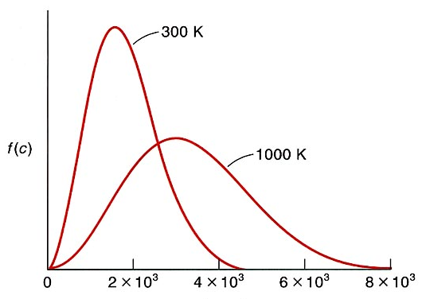
T₂
T₁
- Which of the following temperatures (T₁ or T₂) is higher ?

- What is the approximate value of c_{mp} for each temperature?

- Following the example in the class for calculating mean speed, derive the expression for rms (c) using the Maxwell distribution of speeds.

As we talked in the class:

