Chapter 4 Review Questions
3. What evidence of chemical change is visible when electricity is run through water? (Figure 4.4)
5. Distinguish between potential and kinetic energy.
8. When water boils, bubbles form. What is inside those bubbles?
Chapter 4 Paired Exercises
3. Cite the evidence that indicates that only physical chang s occur when a platinum wire is heated in a Bunsen burner flame.
5. Identify the reactants and products when a copper wire is heated in air in a Bunsen burner flame.
15. How many joules of heat are required to heat 125 g aluminum from 19.0°C to 95.5°C? (Table 4.3)
19. A 135-g sample of a metal requires 2.50 kJ to change its temperature from 19.5°C to 100.0°C. What is the specific heat of this metal?
21. A 155-g sample of copper was heated to 150.0°C, then placed into 250.0 g water at 19.8°C. (The specific heat of copper is 0.385 J g°C.) Calculate the final temperature of the mixture. (Assume no heat loss to the surroundings.)
23. A 110.0-g sample of a gray-colored, unknown, pure metal was heated to 92.0°C and put into a coffee-cup calorimeter containing 75.0 g of water at 21.0°C. When the heated metal was put into the water, the temperature of the water rose to a final temperature of 24.2°C. The specific heat of water is 4.184 J/g°C. (a) What is the specific heat of the metal. (b) Is it possible that the metal is either iron or lead? Explain.
43. Does the following image depict a physical change or a chemical change? 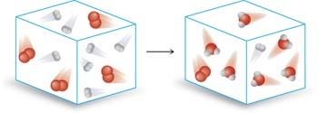
44. Does the following image depict a physical change or a chemical change?
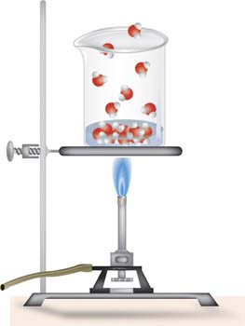

Chapter 5 Review Questions
3. From the chemist’s point of view, what are the essential differences among a proton, a neutron, and an electron? Discuss the location, charge and relative masses of these particles.
4. Distinguish between an atom and an ion.
Chapter 5 Paired Exercises
4. What experimental evidence led Rutherford to conclude the following?
(a) The nucleus of the atom contains most of the atomic mass.
(b) The nucleus of the atom is positively charged.
(c) The atom consists of mostly empty space.
25. An average dimension for the radius of an atom is 1 x 10⁻⁸cm and the average radius of the nucleus is 1 x 10⁻¹³cm. Determine the ratio of atomic volume to nuclear volume. Assume that the atom is spherical $V=\frac{4}{3}πr^{3}$ for a sphere].
28. Given the following information, determine which, if any, elements are isotopes.
(a) mass number = 32: number of neutrons = 17
(b) mass number = 32; number of protons = 16
(c) number of protons = 15; number of neutrons = 16

36. Complete the following table with the appropriate data for each isotope given (all are neutral atoms):
Element | Symbol | Atomic # | Mass # | Proton # | Neutron # | Electron #
 | ³⁶Cl
Gold |  |  | 197
 |  | 56 |  |  | 79
 |  |  |  |  | 20 | 18
 |  |  | 58 | 28

38. Draw diagrams similar to those shown in Figure 5.5 for the following ions:
(a) O²⁻ (b) Na⁺ (c) P³⁻ (d) Ca²⁺
39. Draw pictures similar to those in Figure 5.8 for the following isotopes:
(a) ³He and ⁴He (c) ¹⁰B and ¹¹B
(b) ⁶Li and ⁷Li (d) ¹²C and ¹³C

